REQUEST FOR PROPOSALS FOR

BROADBAND DEPLOYMENT IN

MORGAN COUNTY, OHIO
RFP Issue Date: March 1, 2023

RFP Response Due Date: March 23, 2023

REQUEST FOR PROPOSALS

Morgan County, Ohio (COUNTY) is requesting proposals for broadband deployment from Internet Service Providers (ISP) to expand broadband service throughout Morgan County. Broadband is a critical infrastructure component needed by all segments of the community: for business development; job creation; health care services, including telemedicine; and to help rural areas compete with more densely populated areas. Broadband includes fixed wireless or fiber deployment or a combination of the two (collectively, the “Broadband Infrastructure”).
Specifically, COUNTY is seeking to identify partners to jointly submit an application for the Appalachian Regional Commission’s (ARC’s) Partnerships for Opportunity and Workforce and Economic Revitalization (POWER) Initiative grant application for Fiscal Year (FY) 2023. Up to $2.5 million of POWER grant funding is available for broadband infrastructure. Any selected Respondent will be identified as a project partner in COUNTY’S POWER grant application and will only be awarded a contract for services upon COUNTY’s successful award of a POWER grant.

SECTION I: PROJECT DESCRIPTION

The majority of the build-out must serve economic development interests, which can have a wide range of applications, from traditional commercial business enterprise and manufacturing to agriculture businesses and cottage industries. As a result of the COVID-19 Pandemic, working from home, distant learning, and tele medicine will also be targeted for this project. A secondary focus can include serving residential areas, which should ideally be in conjunction with servicing economic development activities.

Proposals will be judged based upon the ISP capacity to deliver service speed of a minimum of 100/100mb symmetrical to business and 50/10mb for households, the extent of the coverage that they are able to deliver, the pricing for services, and the ability to invest up to 30% of the project total of their private sector and other investments, which may include assets already in place, in-kind services, and cash equity.

The primary scope of this project involves:

High-Level Design
The ISP Partner shall produce a high-level design for the service territory through which the distribution network must pass in order to create the federally necessitated Environmental Review documents.

The high-level design shall, when implemented, provide Broadband Infrastructure cost-effectively to the occupied premises.

The ISP will provide details of the areas to be included, including locations of premises to be served and estimated route mileage.

Permitting
ISPs are expected to obtain all local review and permitting approvals for the project.

Detailed Engineering Construction Design
The ISP Partner shall also produce a detailed network design and engineering plan for the construction of the system. The detailed design and engineering plan shall include, as applicable for fiber deployment, fixed wireless, or a combination of the two, specifications for:
- The fiber distribution network
- Construction maps and splice charts and network electronics.
- The physical infrastructure and environmental systems necessary to house and support the network electronics.
- Fiber connections to customer premises ("drops").
- Customer premises equipment and cabling.
- If proposing wireless network architecture, include incorporation of existing vertical assets through mutually agreeable lease arrangements with the County and the construction of new vertical assets, as needed

Construction
The ISP Partner shall construct the Broadband Infrastructure that conforms with the network design and engineering specifications. Construction shall include all procurement or materials and labor; all utility connections and coordination; all licensing and permits; traffic control, construction and installation of the Broadband Infrastructure; and validation and optical testing.

Customer Premises Installations
The ISP Partner shall install at each customer premises the drop or fiber connection. The ISP Partner shall also install at each customer premises customer premises equipment and inside wiring that are necessary to connect the customer premises equipment in full conformance with the network design & engineering specifications, and technical and operational standards.

Project Management Support
The ISP Partner shall plan, schedule, budget, and obtain final approval from the COUNTY prior to initiating the construction, installation, operation support scope of work described above.

The ISP Partner shall provide leadership and supervision to all resources performing the work to ensure that the work is completed according to plan and the agreement.

The ISP Partner shall report at regular intervals progress to completion, spending against budget, and issues requiring resolution by the COUNTY.

Network Operations
The ISP Partner's operational responsibilities shall include systems integration, operation, maintenance, and coordination of repairs of all network infrastructure, systems, and electronics and periodic replacement of components that no longer operate reliably.

Network operations shall include:
- Technical integration and quality assurance of network electronics and customer premises equipment before live service is initiated.
- Network monitoring, trouble reporting, and dispatch.
- Subscriber usage monitoring and traffic optimization.
- Maintenance and replenishment of spare component and materials inventory for network operations center.

Federal Interest on Materials and Fiber Optics

It is the intent of the COUNTY to transfer ownership of the network and associated components to the winning ISP. This will be accomplished through an agreement developed between the parties.

The use of federal funds to procure and construct the network requires the COUNTY to ensure federal interest into the investment is maintained for the “useful life” of the federal investment, currently defined as seven (7) years for network equipment and twenty (20) years for the fiber optic strands. Consequently, the ISP Partner shall enter into an agreement with the COUNTY to secure this federal interest.

SECTION II: PROJECT PARTNERS/INVESTMENT AREAS

COUNTY will be responsible for the ARC POWER grant administration, which includes development of the Environmental Review and processing project payments.

The Governor’s Office of Appalachia has contracted with Appalachian Management Services to fulfil their role as the required Basic Agency. AMS will review the Environmental Review, process grant funds draw downs, and ensure compliance with federal standards such as site monitoring visits and compliance with procurement and prevailing wages.

The project areas are set forth in Appendix B.

SECTION III: PROJECT SCHEDULE

- All proposals are due by 2:00 pm EST on Friday, March 23, 2023.
- Project implementation schedule and phasing - please provide an estimated project timeline. Estimated time of award is October 1, 2023. Timeline should include:
- Estimated project start and end dates.
- Proposed date(s) for pre-project meeting with COUNTY.
- Proposed date for project completion.

ISP will provide written monthly updates on progress and completed milestones during the work period.

SECTION IV: PROPOSAL RESPONSES

The following will be considered the minimal contents of the proposal:

- Provide a restatement of the goals, objectives, and project tasks to demonstrate the responder’s understanding of the project and your approach to this project. Please reference the Project Description section in your responses.
- Provide your background and experience in the following areas:
  - Coverage Area: summarize your company’s current service area footprint and estimated customer size, both residential and business.
  - Services: describe any direct experience and knowledge your company has in providing residential and business broadband services.
  - Partnerships: share your company’s experience in working with state and local governments and public-private sector collaborations.
- Provide any information on prospective conflicts of interests, including existing or financial relations with equipment vendors, ISPs or other firms.
- Provide a project implementation schedule and phasing. Timeline should include:
- Estimated project start and end dates.
- Proposed date(s) for pre-project meeting with COUNTY.
- Proposed date for project completion.
- Each proposer shall provide a minimum of three (3) references where similar projects have been completed. These projects should be similar in design and scope. Identify key personnel who will conduct the project and provide details of their training and work experience.
- List potential subcontractors (see Appendix C) and include ISP’s and subcontractor’s MBE/WBE certifications.
- ISPs must submit a proposal for services which sets forth options for the greatest extent of broadband service either through fiber, wireless, or mixed coverage in the underserved areas (see Appendix B), clearly delineating the costs per option.

SECTION V: PROPOSAL EVALUATION

The local project partner team and COUNTY will evaluate all proposals using the following criteria to conduct a best-value evaluation:

- Experience and qualifications of the provider. (15 points)
- A clear understanding of this project. (15 points)
- The number of customers to be served. (15 points)
- Speed of service to be provided. (15 points)
- Consumer pricing of service. (15 points)
- Amount of the ISP other investment i.e.: Land & Cash Equity, Existing Assets, etc. (15 points)
- Providing broadband service outside the Investment areas. (20 points)
- Timeline to build out from notice to proceed. (5 points)
- MBE/WBE (5 points)

After evaluating all proposals, the local project partner team, comprised of COUNTY, County representatives, and a third-party consultant may choose to interview the top candidates.

Morgan County reserves the right to accept or reject any, and all proposals or to waive any irregularities and reserves the right to award one ISP per investment area or any combination thereof.

SECTION VI: Proposal Format and Submittal Procedure

All proposals must be electronically generated in a format capable of being used by Morgan County. Respondents must submit one (1) printed paper copies of their proposal and one (1) Portable Document Format (PDF) version of all proposal materials saved on a USB flash drive to the Morgan County Economic Development office in the Riecker Building, Room 135 at 155 E. Main St.
McConnelsville, OH 43756.

Following the RFP Issue Date, Respondents may submit questions regarding this RFP at any time prior to 1:00pm Eastern on March 10, 2023 via electronic mail to the following address (the "County Authorized Representative"): shannon.wells@morgancounty.oh.gov. Any individual who would like to receive future updates on this RFP must submit their name, organization, and email address to the County Authorized Representative by such deadline as well. Questions submitted to the Authorized Representative do not create exceptions to the terms and conditions of this RFP.

All questions submitted to, and answers provided by the County Authorized Representative shall be shared on or before March 15, 2023 with those individuals who submitted their name, organization, and email address in accordance with the requirements above. Respondents shall not contact any person who is an employee, officer, elected official or agent of Morgan County with respect to this RFP, except for the Authorized Representative. The Morgan County Commissioners may disqualify any Respondent who makes such contact.

The deadline for Morgan County's receipt of a Respondent's proposal, in both the printed and PDF versions as outlined above, is March 23, 2023 at 2:00pm. Respondents may submit their proposals any time prior to the above-stated deadline. Failure to submit the required formats and number of copies by this deadline may be subject to disqualification from the RFP process. Morgan County shall bear no responsibility for submitting proposals on behalf of any Respondent. No extensions shall be granted for responses to this RFP.
Each Respondent shall carefully examine the RFP and thoroughly familiarize themselves with all requirements prior to submitting a proposal to ensure that the proposal meets the intent and requirements. Before submitting a proposal, each Respondent shall be responsible for making all investigations and examinations necessary to ascertain conditions affecting the intent and requirements. Failure to make such investigations and examinations shall not relieve the Respondent from its obligation to comply, in every detail, with all RFP provisions and requirements.
It is the Morgan County Commissioners' intent to commence final negotiations with the Respondent deemed most advantageous to Morgan County and most likely to deploy broadband to the most County locations (the "Awardee"). Morgan County reserves the right to conduct post-proposal discussions with any Respondent.

Section VII: Terms, Conditions, Limitations and Exceptions
- This RFP does not commit Morgan County to issue an award or to pay any costs incurred in the preparation of a proposal in response to this RFP.
- The proposals will become part of Morgan County's official files without any obligation on Morgan County's part.

- All proposals received and any or all supporting documentation are subject to the State of Ohio Public Records Act and the provisions of Ohio Law. The County will use reasonable due diligence where lawful to protect materials clearly marked by any Respondent as "proprietary," "trade secret "or "confidential". General technology approach or business model information does not constitute "proprietary," "trade secret" or confidential information.

- Respondent(s) shall not offer any gratuities, favors, or anything of monetary value to any official or employee of Morgan County.

- Respondent(s) shall not collude in any manner, or engage in any practices, with any other Respondent(s) or Third Party, which may restrict or eliminate competition or otherwise restrain trade. This is not intended to preclude subcontracts and joint ventures for the purposes of: (1) responding to this RFP, or (2) establishing a project team with the required experience and/or capability to provide the services specified herein. Conversely, Morgan County can combine or consolidate proposals, or portions thereof, for the purposes mentioned herein.
- All proposals submitted must be the original work product of the Respondent. The copying or paraphrasing of the work product of another Respondent is not permitted.
- The RFP and the related responses of the selected Respondent may by reference become part of any formal agreement between the selected Respondent and Morgan County. Morgan County and the selected Respondent may negotiate a contract or contracts for submission to Morgan County for consideration and approval. In the event an agreement cannot be reached with the selected Respondent, Morgan County reserves the right to select an alternative Respondent. The County reserves the right to negotiate with alternative Respondent(s) the exact terms and conditions of the contract.

- Respondents, their authorized representatives, and their agents are responsible for obtaining, and will be deemed to have full knowledge of the conditions, requirements, and specifications of the RFP at the time a proposal is submitted to Morgan County.
- Morgan County may terminate its review of a Respondent's proposal or an Awardees' performance under a contract in the event of a default by the Respondent or Awardee and a failure to cure such default after receiving notice of default from Morgan County. Default may result from the Respondent's or Awardee's failure to perform under the terms of the contract or from the Respondent or Awardee becoming insolvent, having a substantial portion of its assets assessed for the benefit of creditors, or having a receiver or trustee appointed.
- Morgan County reserves the right to unilaterally disqualify any Respondent who in Morgan County's opinion fails to provide information or data requested or who provides materially inaccurate or misleading information or data. Further, Morgan County reserves the right to unilaterally disqualify any Respondent based on any real or apparent conflict of interest that is disclosed by the proposal submitted or any other data or information available to Morgan County. This disqualification is at the sole discretion of Morgan County. By submission of a proposal hereunder, the Respondent waives any right to object now, or at any future time, before anybody or agency, including but not limited to, Morgan County's elected officials, officers, agents, or employees, or any court, as to the exercise by Morgan County of such right to disqualify or as to any disqualification by reason of real or apparent conflict of interest determined by Morgan County.

- Morgan County shall have the unilateral right to reject any Respondent RFP response including, but not limited to the following:
  - Failure to submit the RFP response for Morgan County to receive it by the deadline of March 23, 2023 at 2:00pm.
  - Failure to submit the RFP response to the correct location.
  - Failure to submit the RFP response in the prescribed formats and number of copies.
  - Failure to include all requested information.
  - Taking exception to the terms, conditions, and specifications herein.

NOTE: Any deviation/ omission from the preceding list may void a Respondent response.

The issuance of this RFP and the acceptance of a proposal does not constitute an agreement by Morgan County that any contract or other agreement will be entered into by Morgan County. The County expressly reserves the right to:
- Reject any or all proposals.
- Reissue the RFP.
- Accept portions of individual or multiple RFP responses.
- Request more information and/or clarification of proposals from any or all Respondents.
- Waive immaterial defect(s) or informality(ies).

The foregoing granting of exclusive negotiation rights does not commit Morgan County to accept all or any of the terms of the proposal(s). Final terms of any agreement will be agreed upon during negotiations. Negotiations may be terminated at any time by Morgan County for failure to reach mutually acceptable terms.
- Morgan County reserves the right to request clarification of any proposal after all proposals have been received.
- Morgan County reserves the right to select elements from different individual proposals and to combine and consolidate them in any way that best serves Morgan County's interest. Morgan County reserves the right to reduce the scope of the project and evaluate only the remaining elements from all proposals. Morgan County reserves the right to reject specific elements contained in all proposals and to complete the evaluation process based only on the remaining items.

- Any disputes arising out of this agreement that result in litigation shall attorn to the jurisdiction of an appropriate court either state or federal, for Morgan County, Ohio.

- This RFP, the responses thereto, and any awarded contract thereunder shall for all purposes be construed and enforced in accordance with the laws of the State of Ohio and the United States of America without regard to conflict of law principles. All Respondents shall comply with any and all applicable orders, rules or regulations of the Federal Communications Commission ("FCC"), Public Utilities Commission of Ohio ("PUCO"), and Federal and State law in submitting a response to this RFP, and during the term and in performance of any contract awarded as a result of this RFP. The Awardee shall adhere to the requirements of the American Rescue Plan Final Rules, and the requirements of all further guidance issued by the U.S. Department of Treasury, or other applicable federal agency, on the American Rescue Plan, should Morgan County utilize American Rescue Plan funds in issuing an award under this RFP.

- Entities submitting proposals must have the capacity to enter into a legally binding contract. All contract(s) amount(s), if any, resulting from this solicitation will be paid directly to the entity submitting accepted proposal(s). In any accepted proposal(s), to authorize payments directly to another third party upon contracting the proposing entity may be required to fully execute such proper payment authorization forms as acceptable to Morgan County.

- The County reserves the right to conduct, for security reasons, a lawful background investigation on the selected Respondents, its principal party, personnel or subcontractors. Respondents agree to cooperate with Morgan County in this endeavor and to provide any permitted, reasonably necessary information. The County will, upon the Respondent's written request, provide a copy of such background investigations to the Respondents, to the extent allowable by law. Dependent upon the results of the background check, Morgan County may request the Respondents to immediately remove an individual from participation on this project. Respondents shall not knowingly assign any personnel with records of criminal conviction(s) to this Project without advising Morgan County of the nature and gravity of the offense. In fulfilling the obligations under this section, Morgan County and the Respondents shall comply with all laws, rules, and regulations relating to the making of investigative reports and the disclosure of the information contained therein. Morgan County and the Respondents shall, if allowed by law, indemnify, defend, and hold each other harmless against any wrongful disclosure by the indemnifying party, its employees, and/or agents of said reports and the information contained therein.
- All selected Respondents shall be required during the project to cooperate fully, and in any reasonable manner Morgan County shall request, with all Morgan County officials, officers, agents, employees, contractors, subcontractors and volunteers. Further, selected Respondents shall be required to coordinate their implementation(s) with all other selected Respondents and all other projects that are being undertaken by Morgan County. If any problem or difficulty should arise regarding such attempts at cooperation and coordination, Morgan County shall be immediately informed and will determine the way the parties are to proceed.

SECTION VIII: OTHER REQUIREMNENTS

INSURANCE REQUIREMENTS
Worker's Compensation Insurance - The ISP contractor shall provide Worker's Compensation Insurance where required and shall accept full responsibility for the payment of premiums for Worker's Compensation Insurance and Social Security, as well as income tax withholding and any other taxes or payroll deductions required by law for its employees who are performing services related to the project.

General Liability & Property Damage Insurance
The ISP contractor will provide and maintain comprehensive general liability and property damage insurance in the minimum amount of $250,000.00 per person for injury and death in a single occurrence;
$1,000,000.00 per occurrence for injury or death of more than one (1) person in a single occurrence; and $500,000.00 for a single occurrence of property damage, and which
shall be endorsed to protect the commonwealth.

Flood Insurance
If the project is wholly or partially within a floodplain, proof of sufficient flood insurance coverage must be provided. In any case, a project is required to provide a copy of a floodplain map of the project area, with the project site being delineated thereon.

Identify Morgan County as an Additional Insured: The County shall be listed on the above insurance policies as an additional insured. Upon request, the Grantee shall furnish proof of insurance as required by this section to the County Clerk.

FEDERAL & APPALACHIAN REGIONAL COMMISSION (ARC) COMPLIANCE GUIDELINES

DAVIS BACON ACT (Federal Wages)
The ISP Partner and any of it’s sub-contractors (if any) shall comply, as applicable, with the provisions of the Davis Bacon Act (40 U.S.C. §§276a to 276a- 7), the Copeland Act (40 U.S.C. §276c and 18 U.S.C. §874), and the Contract Work Hours and Safety Standards Act (40 U.S.C. §§327-333) regarding labor standards for federally assisted construction sub agreements.

Please see Appendix D for the Davis Bacon Prevailing Wage Rates that are effective on the release date of this RFP.

BUY AMERICAN ACT
As required by the Buy American provision, all products must be of domestic origin as required by 7 CFR Part 210.21(d). (210.21(d).

Exceptions to the Buy American provision should be used as a last resort; however, an alternative or exception may be approved upon request. To be considered for the alternative or exception, the request must be submitted in writing to a designated official, a minimum of 30 day(s) in advance of delivery.

The request must include the:
- Alternative substitute(s) that are domestic and meet the required specifications:
- Price of the domestic alternative substitute(s); and
- Availability of the domestic alternative substitute(s) in relation to the quantity ordered.

- Reason for exception: limited/lack of availability or price (include price):
- Price of the domestic product; and
- Price of the non-domestic product that meets the required specification of the domestic product

AMERICANS WITH DISABILITIES ACT (ADA)
The ISP contractor agrees to comply with the General Prohibitions Against Discrimination, 28
C.F.R. § 35.130, and all other regulations promulgated under Title II of The Americans with
Disabilities Act which are applicable to all benefits, services, programs, and activities provided by
the commonwealth through contracts.

Will comply with all Federal statutes relating to nondiscrimination. These include but are not
limited to:
- Title VI of the Civil Rights Act of 1964 (P.L. 88-352) which prohibits discrimination on the
basis of race, color or national origin;
- Title IX of the Education Amendments of 1972, as amended (20 U.S.C. §§1681 1683 and 1685-1686) which prohibits discrimination on the basis of sex;
- Section 504 of the Rehabilitation Act of 1973. as amended (29 U.S.C. §794). which
prohibits discrimination on the basis of handicaps;
d) the Age Discrimination Act of 1975. As amended (42 U.S.C. §§6101-6107). which
prohibits discrimination on the basis of age;
e) the Drug Abuse Office and Treatment Act of 1972 (P.L. 92-255). As amended, relating to
nondiscrimination on the basis of drug abuse;
f) Comprehensive Alcohol Abuse and Alcoholism Prevention. Treatment and Rehabilitation Act of 1970 (P.L. 91-616). as amended, relating to nondiscrimination on the basis of alcohol abuse or alcoholism;
g) Title VIII of the Civil Rights Act of 1968 (42 U.S.C. §§3601 et seq.). as amended, relating
to nondiscrimination in the sale, rental or financing of housing;
i) any other nondiscrimination provisions in the specific statute(s) under which application
for Federal assistance is being made; and the requirements of any other nondiscrimination statute(s) which may apply to the use of the federal funds.

Other Requirements Upon Award of the Contract

For the purposes of initiating the required Environmental Review process, no later than 45 days after award of the contract, the winning ISP will provide the “high level design” (schematic diagram) showing design components of the system including, but not limited to:
- Physical configuration of the system and all potential residential and commercial hookups.
- Proposed new construction locations showing existing property and rights of way lines.
- A schedule listing all vertical assets being used, which shall include existing or proposed and
if it is ISP owned or acquired by lease to gain access.
- Proposed final design and construction schedules

APPENDIX A

ISP RESPONDENT PROPOSAL

Company NAME:

ADDRESS:

TELEPHONE:

REPRESENTATIVE:

Please answer the questions below for project proposal.

Project Area:

- Number of customers to be served:

- Speed of service to be provided:

- Amount of ISP other investment

- Consumer pricing of service:

- Service outside target area Yes No

Est #:

I, , an authorized representative of the above indicated firm, have reviewed, and understand the Rural Broadband Deployment in Morgan County’s Request for Proposal, and I/we am/are prepared to provide the required services for the above costs.

Signature: Date:

APPENDIX B
INVESTMENT AREAS

Current areas that lack the federal minimum level of coverage are indicated below: 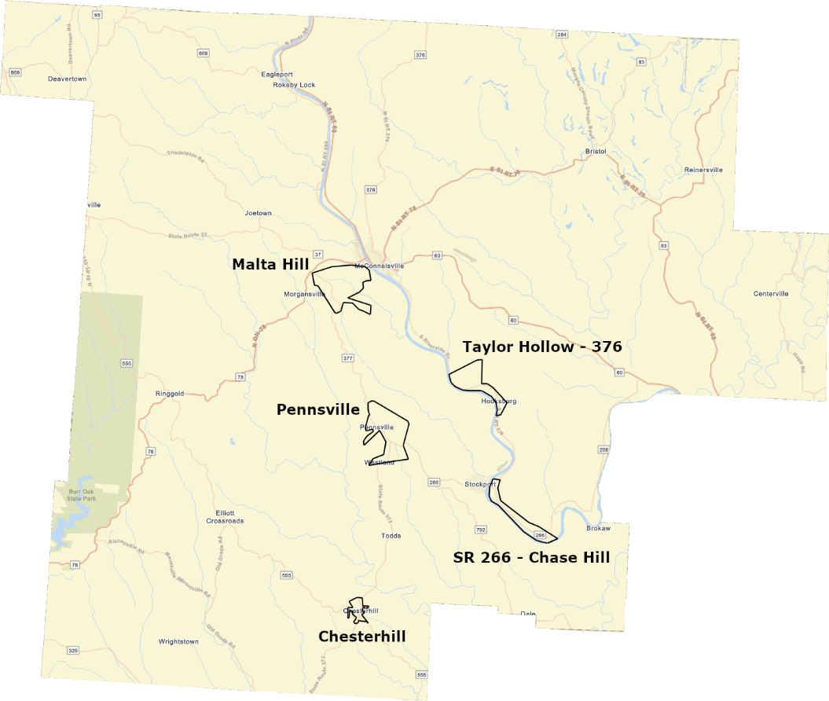

Morgan County 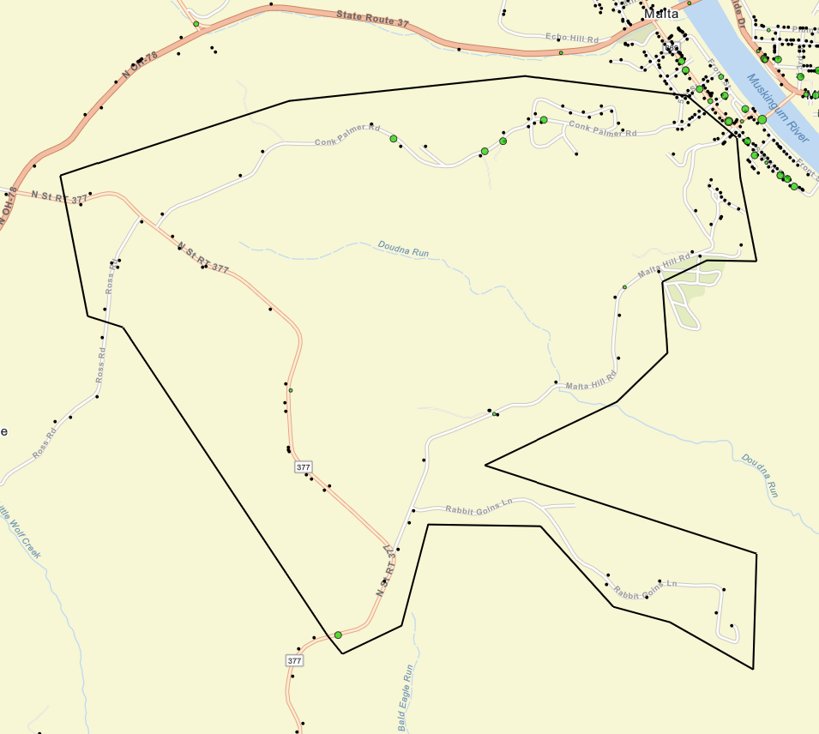Malta Township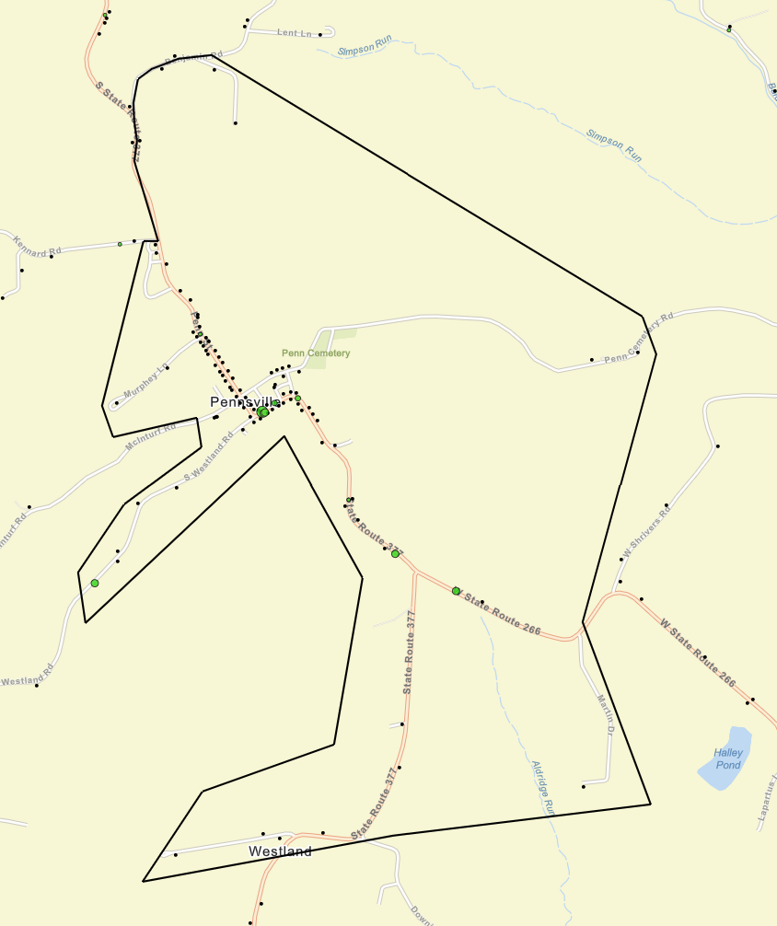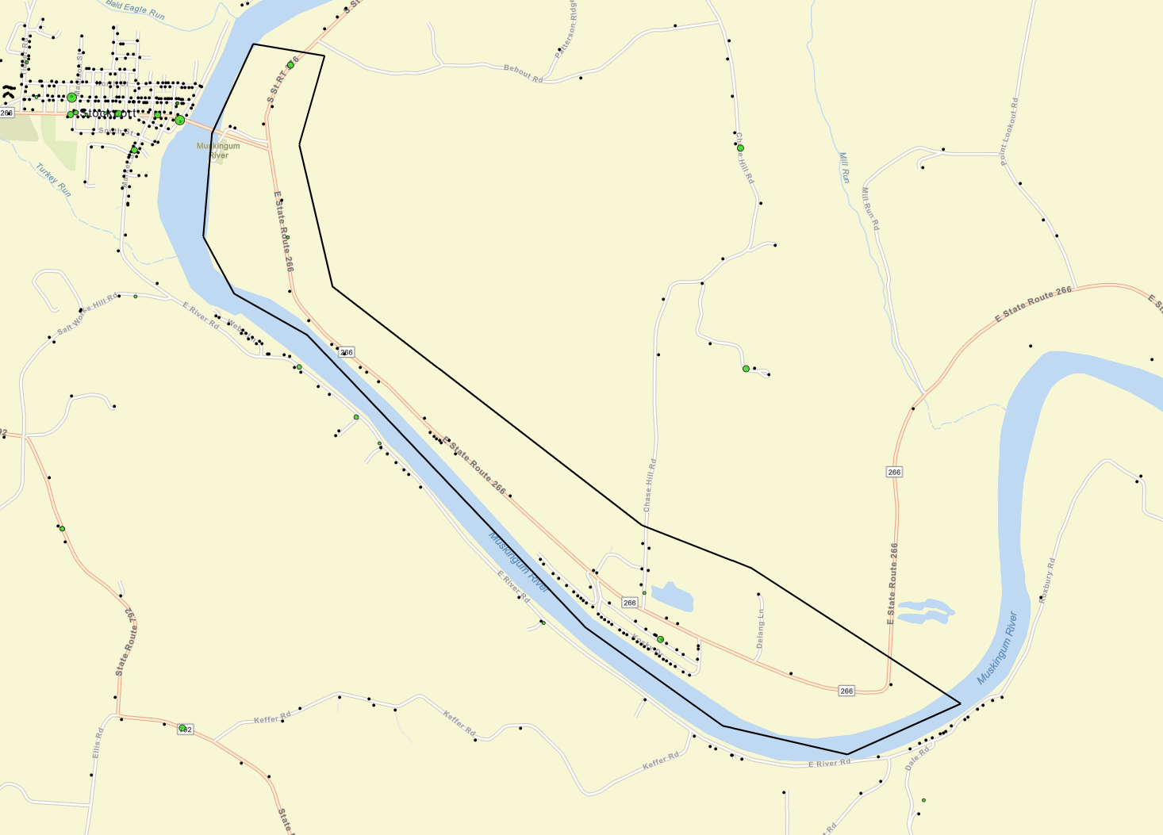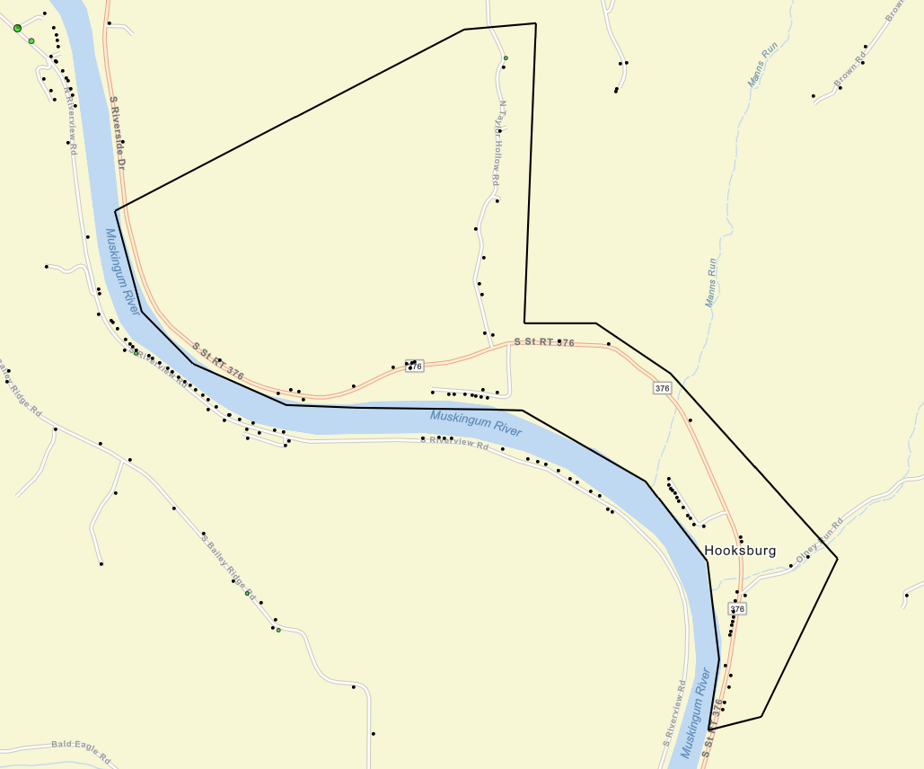

COUNTY is specifically looking at investment in the Village of Chesterhill and the Townships of Penn, Malta, Windsor, and Meigsville, though other areas may be included provided that they are not currently receiving coverage at federal minimum levels.

APPENDIX C
Sub-contractors

For known subcontractors
Name of Sub-contractor | Contract Work Types  (Business of Profession) | Approximate  Dollar Amount | MBE/WBE?

For Yet known subcontractors
Contract Work Type  (Business of Profession) | Approximate  Dollar Amount

I, , an authorized representative of the above indicated firm, have reviewed, and understand the Rural Broadband Deployment in Morgan County’s Request for Proposal, and I/we am/are prepared to provide the required services for the above costs.

Signature: Date:

APPENDIX D
DAVIS BACON PREVAILING WAGES

Attached as a separate document

